Basch scripts task 2 :
1 Execute all scripts from the devops-cloud-documents- channel.
Basic Shell Scripts:
Output to screen
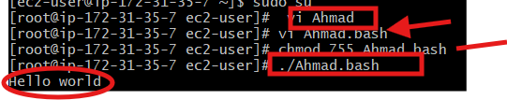
Frist You need to create file With The command
Vi filename.bash and edit in the
Give The permission 755 with the command
Chmod 755 filename,bash
To excecute the script Command is ./filename.bash

Defining Tasks :
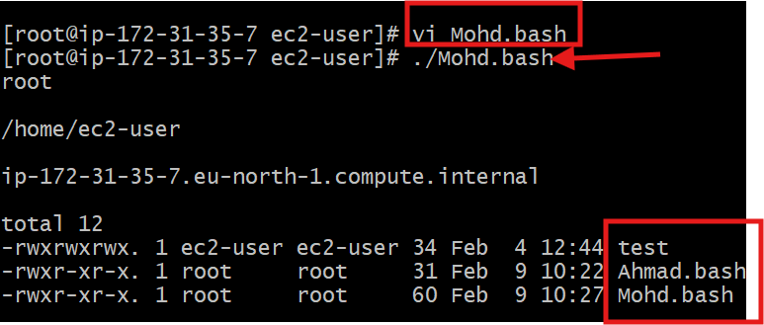\
Defining variables:
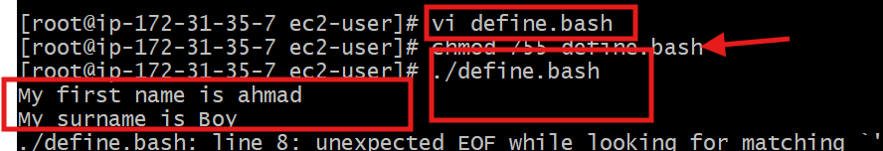
Read Input:
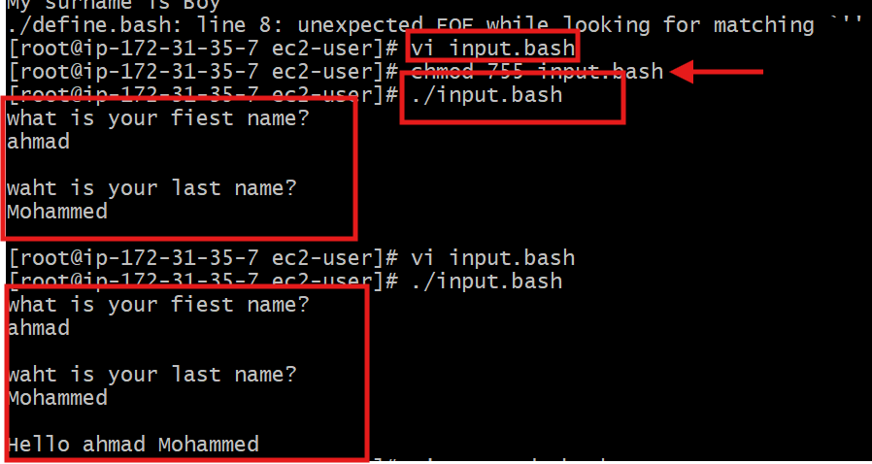

Scripts to run commands within:
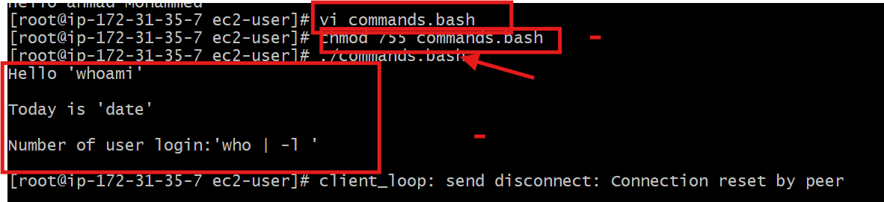
Read input and perform a task
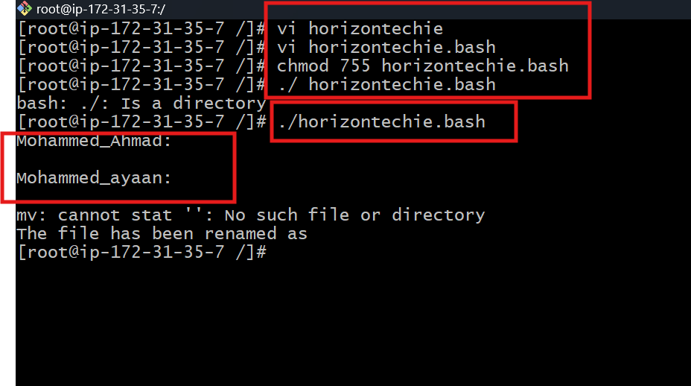

do-while Script
Script to run for a number of times
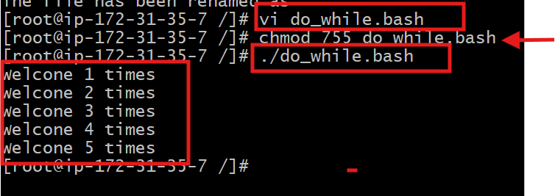

Script to run for a number of seconds
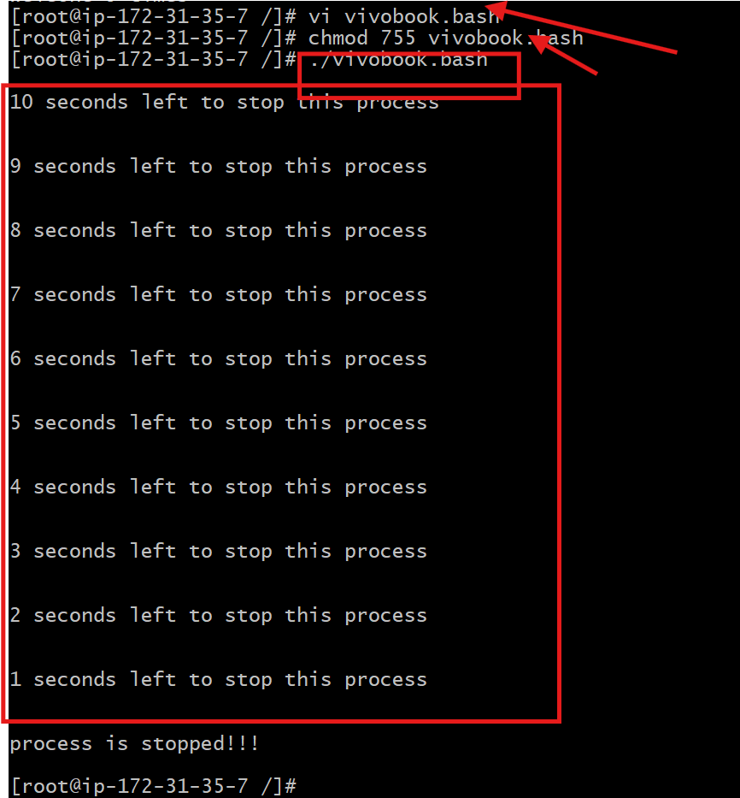
If-then Scripts:
Check the variable
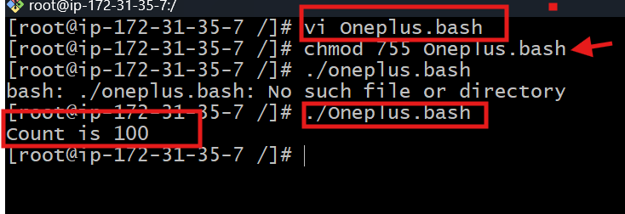
Check if a variable value is met

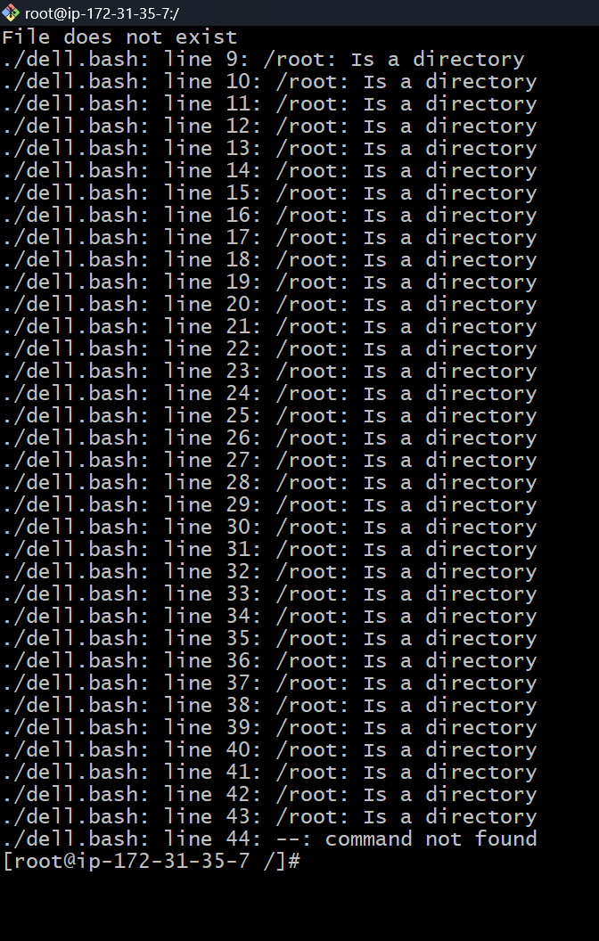

Check the response and then output
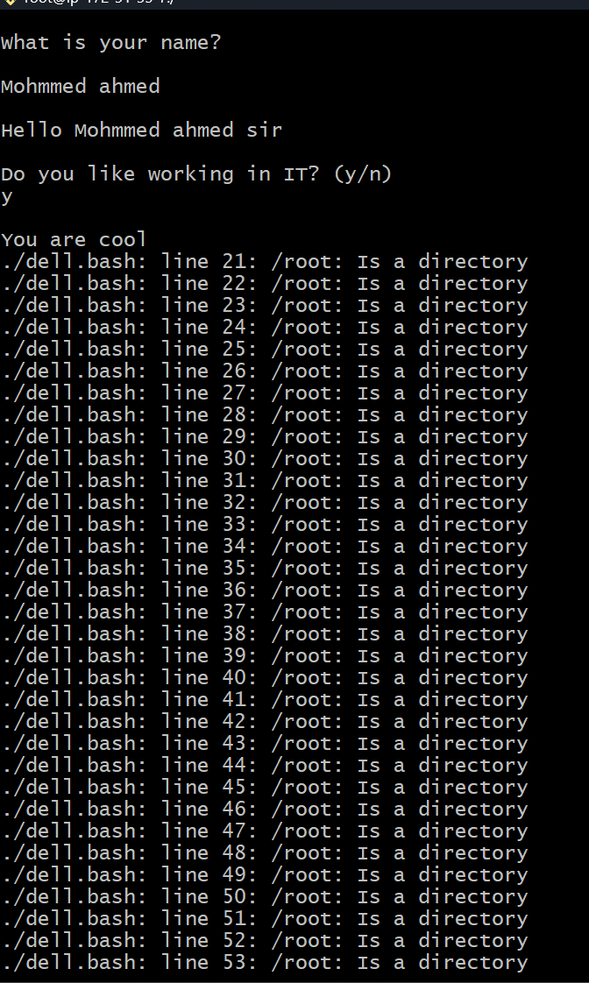
case Scripts:
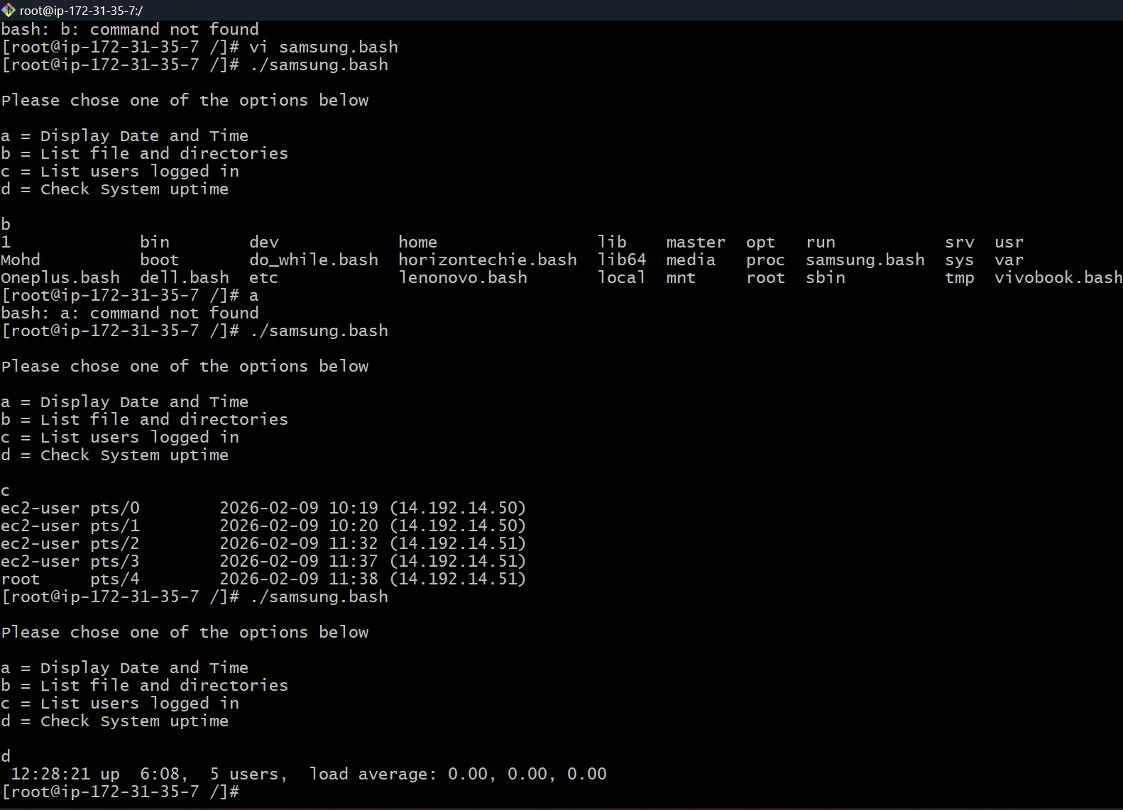

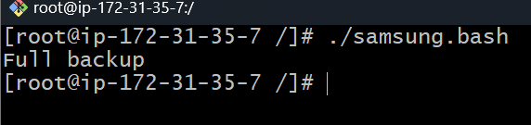

for loop Scripts:
Simple for loop output
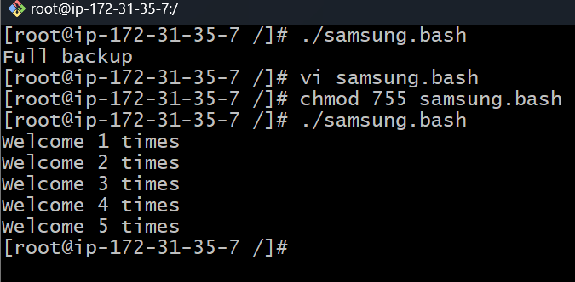

Specify days in for loop
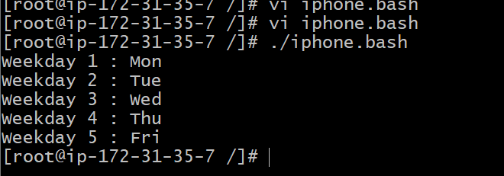
List all users one by one from /etc/passwd file
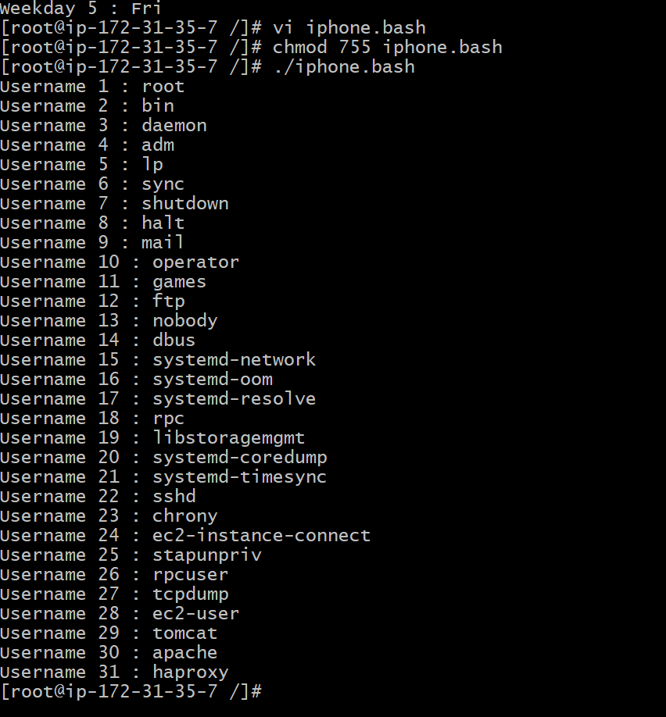

2 Create a bash script to check if a directory is available or not.
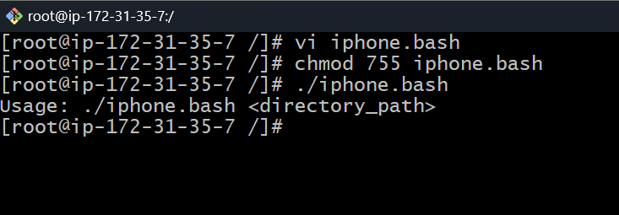
3 Create a bash script to create multiple files.
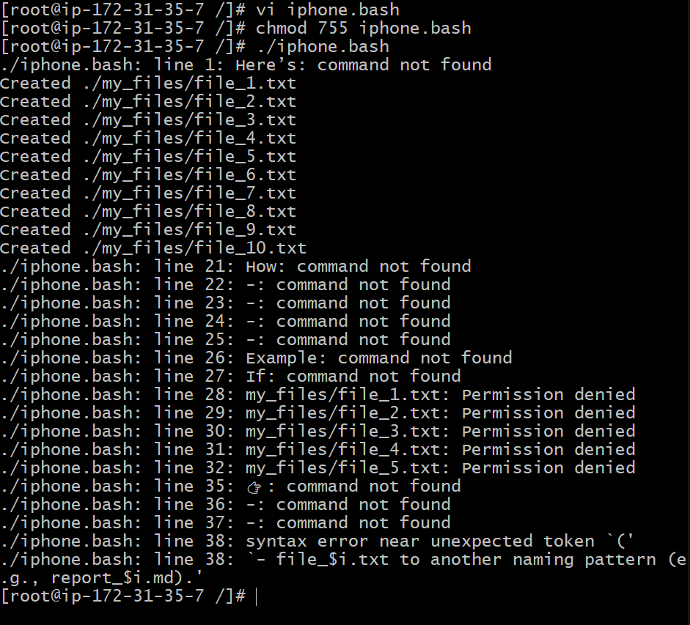

4 Create a bash script to install Nginx on an EC2 server.
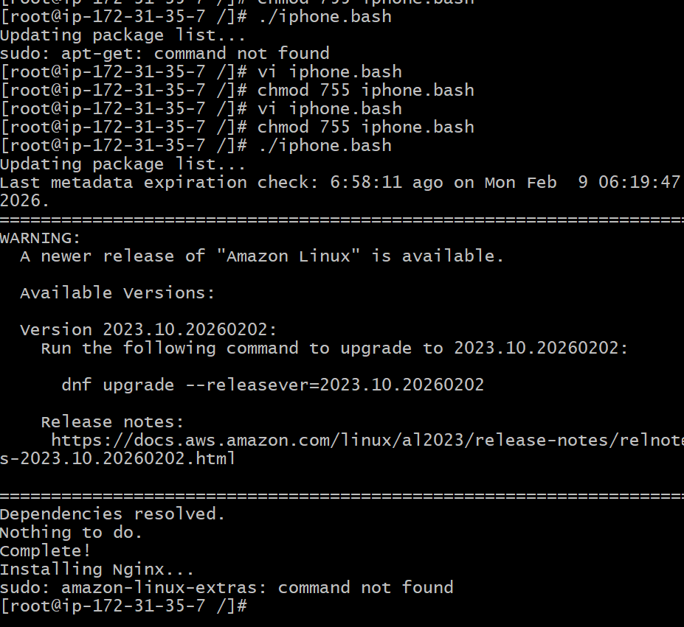

5 Create a bash script to install Apache Tomcat on an EC2 server.
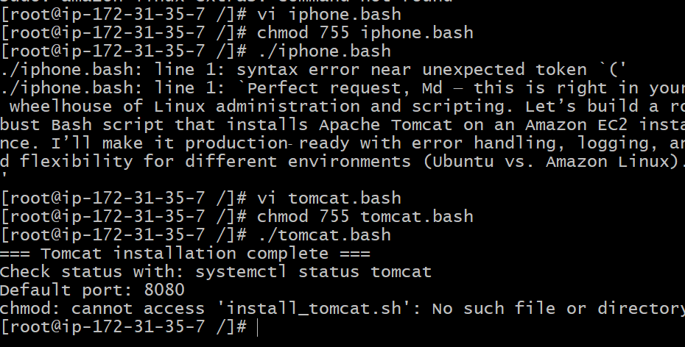
6 Create a bash script to check if the Nginx service is running, if not running then script should start the service.
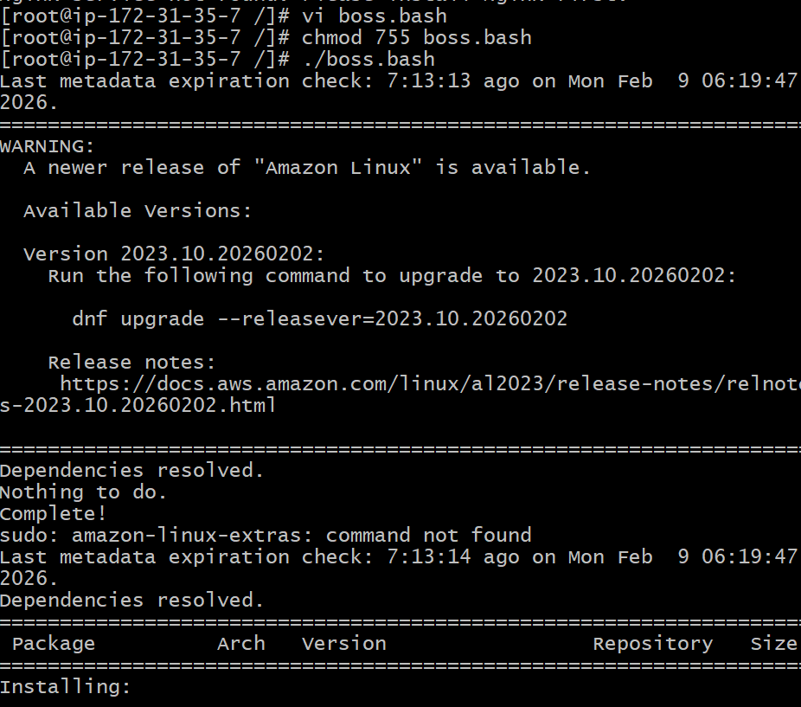
7 Create a bash script for a calculator.
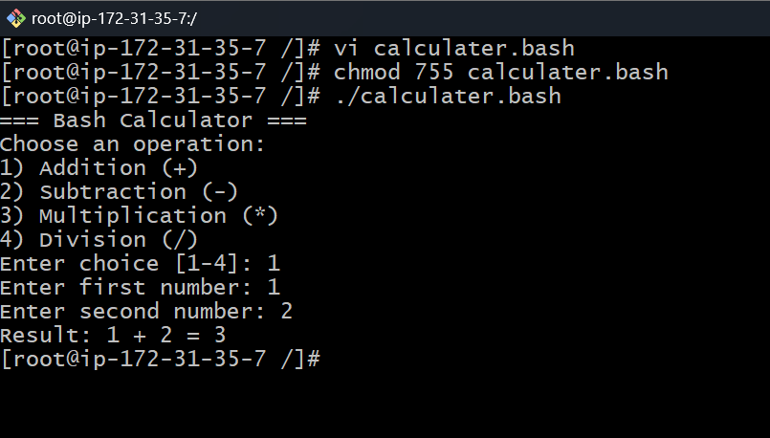
- Create a bash script to check if a directory exists, if not then create a directory.
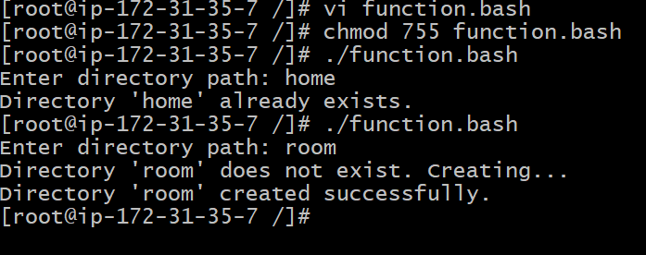
- Create a bash script to delete the last 3 lines of a file.
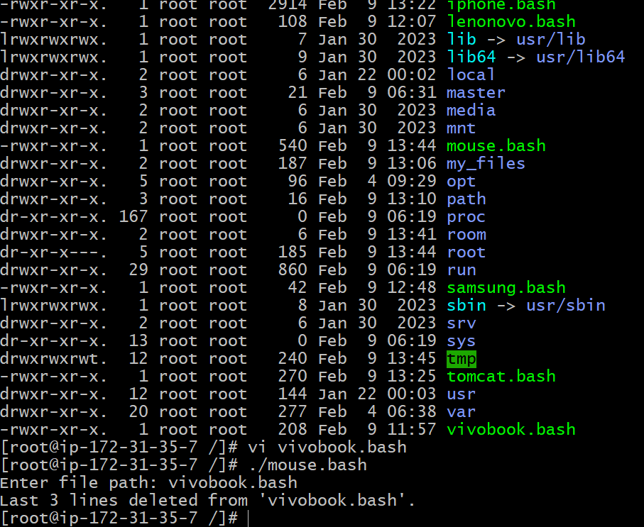
- Bash script to monitor cpu and if it is more than 80% then send email notification.
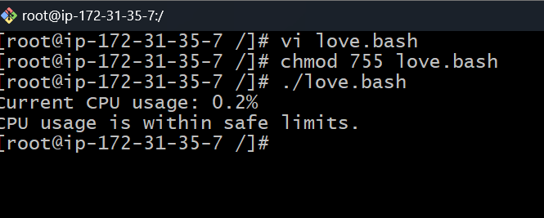
- Bash script to monitor disk space and if it is more than 80% then send email notification.

12 Bash script to monitor memory and if it is more than 80% then send email notification.

13 Exercise: Crontab Entries
April 5th Midnight
5th of Every November, January, June if it is a Thursday
- At 05 and 27th minutes of 9, 10, 11 hours every day
34 minutes of 9th hour on 15th August
Every midnight
- Every Weekend (Saturday night 11:59 PM)
- After every reboot
